COSMIC WALL CLIMB II 5.6 – CASTLE CRAGS

Castle Crags State Park, Mt. Shasta, California
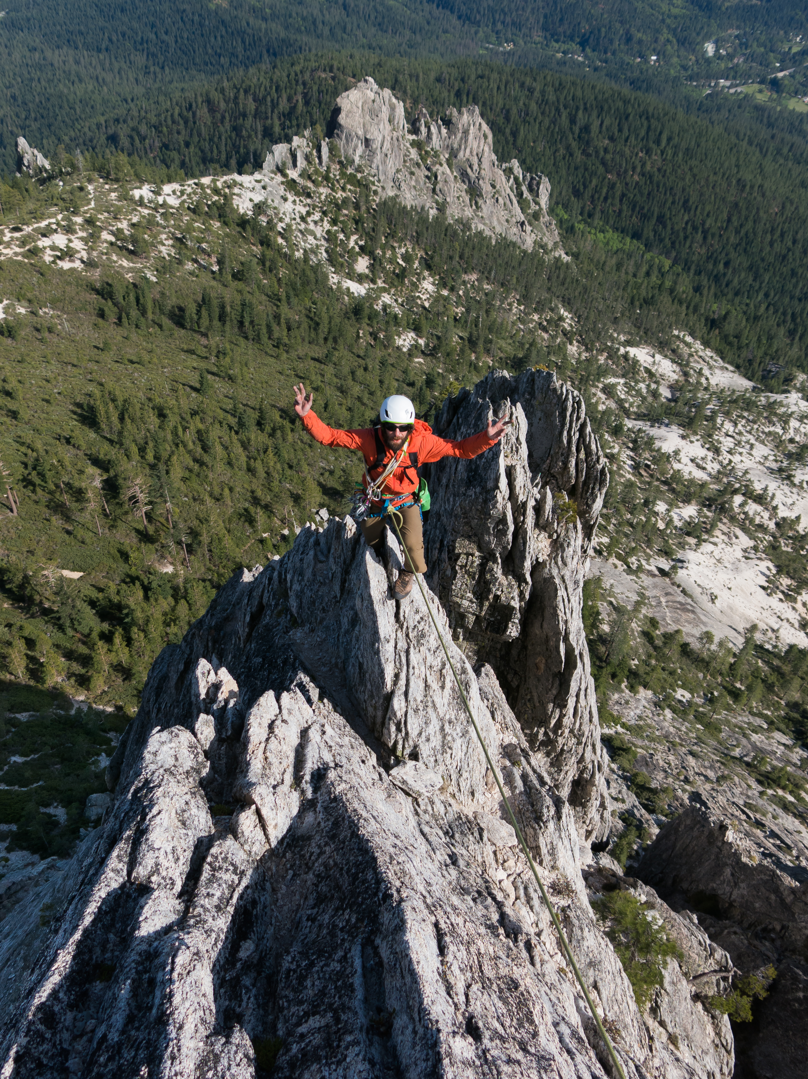
Northern California, with some of the best views anywhere in the Castle Crags Area. As a result, a Cosmic Wall climb has become a rite of passage for California climbers. A guided ascent of the Cosmic Wall starts with a moderate approach through the forest, bringing you to a wild meadow ringed by granite towers. At the far end of this field, Mt., Hubris stands guard over the Eastern end of the Castle Crags range. Our six-pitch climb ascends the black dike up the center of the mountain. The route features moderate climbing, spectacular views, and an exciting exposed arête to the summit. A guided day climbing the Cosmic Wall finishes with a two-pitch rappel directly from the summit and an easy hike back to the car. While a guided climb of the Cosmic Wall is a must-do for any aspiring climber, the Castle Crags Wilderness offers multiple other additional climbs to explore in the Castle Crags Wilderness.

Departure: Mount. Shasta, California
Group Size: Limited to 2- 4 clients
Guide to client ratio: 1:2
Experience Level: Solid rock climbing skills, ability to follow 5.7, proper knots, belays, and good physical conditioning.
Best Season: Cosmic Wall is best climbed in Spring- May / June and September// October - with July & August but can be a bit warm.
A 1/2 day Pre-Climb Rock Clinic is available prior to the climb - Check website for prices and dates: californiarockguides.com or give us a call.

